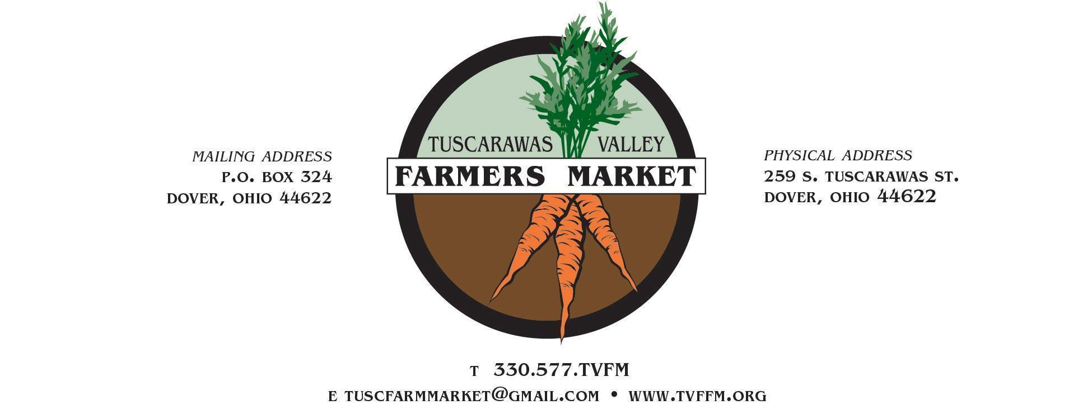
Tuscarawas Valley Farmers Market Guidelines

Mission Statement: The Tuscarawas Valley Farmers Market is designed to bring together families, neighbors, visitors, and local food producers to create a sense of community and social gathering, enhancing our quality of life and strengthening our local food economy. We encourage a partnership between buyers and growers of local farm products that benefits consumers and producers. We strive to serve culturally and economically diverse populations and to increase fresh, locally produced, nourishing, and safe foods for all people including children, the elderly, and families of all incomes.

Introduction: The Tuscarawas Valley Farmers Market management team (herein known as the “Market”) would like to invite the vendors who participate in this market to help it succeed based on integrity and trust. With integrity and trust being the focus of market relationships, the Market wishes to keep our market guidelines to a minimum. Many markets have lengthy rules and regulations that are encumbered with awkward legalese, which may have developed due to breaches in trust. We are asking our vendors to help us build an authentic, producers-only market for the benefit of all who participate. The Market Management Team functions as a facilitator only. We do not accept vendors based on their cultural practices, we exercise no influence on vendor prices, and we do not endorse any political agendas. We are here to assure the vendor and their customers that they will have a safe and consistent venue in which to build their relationships.

Market Bio: The TVFM is a producers-only market that was started in 2008. The market is held at the Tuscarawas County Fairgrounds (entrance on Tuscarawas Avenue). The location offers ample parking, shade, electric, water, and restrooms. Vendor spaces are approximately 12’x12’. A limited number of permanent spaces under roof are available. We do our best to accommodate each vendor's specific requests, however precedence is given to those who are at the market full time. The market is open every Wednesday from 3:00 to 7:00pm from June through mid-October, except for one week in mid-September during the Tuscarawas County Fair.

Becoming a Vendor: Applications are reviewed December-May, yet are accepted on a rolling basis throughout the year. Please note that the market season and the applicant review process take time. Application status updates will not be provided, so we kindly ask that you do not email regarding the status of your application. When you click submit, you will see a receipt that your application has been submitted.

Non-Profit Organizations:
The Tuscarawas Valley Farmers Market (TVFM) welcomes community partners and non-profit organizations to share their mission with the community, provided their mission aligns with the values and goals of the market. Non-profit organizations interested in participating should complete the vendor application.
Non-profits wishing to provide education and raise awareness about their organization may attend on market days scheduled in advance with the TVFM Board at no cost, providing that they are recognized as a non-profit by the state and federal government. Non-profits intending to sell goods will be considered vendors and must apply and meet all vendor requirements.
NOTE FOR RETURNING VENDORS: ALL APPLICATIONS ARE DUE NO LATER THAN MARCH 1st.
If you are a returning vendor, it is important to honor this request. Each year, we receive new applications, and we have a file of applications that have been turned down due to duplication of product. Failure to submit your application by this date may result in your space being assigned to another vendor.

Vendor Guidelines:
- Market hours are 3:00 to 7:00pm. For the purposes of safety and consistency, vendors must be set up and have all vehicles moved from the market walkway by 2:45pm. Failure to do so could result in injury to our customers and will not be tolerated. If you do not comply, you will be assigned to an end space if one is available, otherwise you will be required to carry your products by hand to your vendor space. If you are consistently in violation, the TVFM reserves the right to revoke your application.

- NO EARLY SALES ARE PERMITTED! This is to provide consistency regarding market hours. You may not pre-bag an order for a customer or allow a customer to pre-bag his or her own order before 3:00pm. Failure to follow this guideline could result in a revocation of your application. The exception to this guideline is selling to the chefs participating in that day’s cooking demonstration or the food truck concessionaires, as we encourage them to use ingredients from the market.

- All approved vendors must provide proof of liability insurance with coverage of at least $1,000,000 or sign an ‘Indemnification Form’. The policy must cover the vendor’s business and employees and list the Tuscarawas County Agricultural Society and the Tuscarawas Valley Farmers Market harmless in the event of a legal action brought against the vendor.

- Vendors accepted to participate in the Tusc Valley Farmers Market are required to be present at the market. If a vendor is unable to attend, an approved employee may represent the business. Prior to the start of the market season, all vendors must submit an approved employee list, introduce those employees to the board, and provide verification that each employee is on the business’s payroll.

- In order to clearly communicate with customers, all vendors agree to identify their farm/business name and location, and all selling prices are to be clearly marked on your items.

- The Market reserves the right to prohibit anyone from selling or any product from being sold.

- Hazardous substances are not allowed on the market site.

- The Market is not responsible for loss or damage to booth and/or products due to theft, weather conditions, etc.

- The Market does not guarantee vendor sales.

- All vendors are responsible for acquiring any permits or licenses that may be required by the agencies governing sale and production of the products being sold. If you are unsure of potential licensing and food safety laws that are applicable for your product, please contact the Tuscarawas County Health Department (330-343-5550 x.127) or the Ohio Department of Agriculture, Food Safety Division (614-728-6250). For more information regarding food safety, permits and/or licenses, visit https://www.tchdnow.org/food-safety-program.html. The TVFM management team does not have the legal authority to interpret or enforce the guidelines or laws that apply to your products. In the interest of public safety, fairness, and integrity, the Market has always and will always welcome regulatory agencies to the market to ensure compliance.

- All vendors must provide advance notice by filling out the “TVFM Vendor Vacation Notice Form” by June 1, 2025. If a vendor cannot attend a market date, they must notify the vendor liaison one week prior to the next market. Failure to do so will result in the absent vendor being charged the vendor fee of $1. You may contact the vendor liaison by phone (614)507-2201 or email (tuscfarmmarket@gmail.com). If a vendor has multiple absences without notification, the market team may revoke the vendor’s spot at the Tuscarawas Valley Farmers Market

- Vendors must stay for the duration of the market day. Exceptions will be made for extenuating circumstances related to weather conditions that create a safety risk Please do not pack up early. Many times, customers arrive just minutes before 7:00pm.

- It is imperative that you attend the days you have committed to. We advertise on your behalf about the products available based on the information you provide.

- As a local farmers market, all products must be grown/produced within 75 miles of Dover/New Philadelphia, Ohio, unless special approval is gained from the Market.

- Any vendor selling food products (or plants that may become food) may choose to take part in the Ohio SNAP (food stamp) program. Please visit the market information booth to sign up at no cost to you.

- There are no live animal sales at the market.

Farm/Vendor Visitation: The TVFM management team reserves the right to visit all farm/vendor facilities. Visitations will be completed by a member of the management team on a mutually agreed upon date and time with the vendor.

Value-Added Products: The TVFM welcomes value-added agriculture products. These products are created when the original form of a product or group of products has been altered. This process involves a specialized skill set with knowledge of the raw product that is being used in the process to create a unique, quality end product. Although it is not required to produce your own raw product(s) for this purpose, the TVFM will give preference to products obtained and grown locally. Vendors should have a clear knowledge of the source of their raw product(s). Value-added products must be produced within any licensing requirements for Ohio and Tuscarawas County and in compliance with labeling laws and safe food handling and storage practices.
Value-added products do not include crafts for the purposes of the TVFM.

Resale: THIS IS A PRODUCERS-ONLY MARKET! Buying and reselling in any form will not be tolerated. If you are not the author of a product, you may not sell it. Failure to comply may result in the revocation of your application. This guideline is non-negotiable and will be enforced should we observe it in practice. Should you observe another vendor reselling, please follow the process laid out in the Conflict Resolution section of these guidelines.

Vendor Space Fees: Vendors pay $20 per market day for each 12’x12’ space. Fees will be collected on each market day. All vendor fees are used by the Market for advertising and promotion of the market.
Please note: A $100 security deposit is required of all new, full-time vendors and a $50 deposit for all new, part-time vendors. If you fulfill your commitment (attend ALL market dates that you committed to by June 1, 2025), the full amount will be returned to you at the conclusion of the season.

Full-Time Vendors: Must commit to being present at EVERY market day (with the exception of emergencies/illness). These vendors will have permanent booth locations.

Seasonal Vendors: Those who specialize in a particular product that is available for only a limited time during the season (ex. blueberries, raspberries, etc.).

Part-Time Vendors: Those who can commit to sell only once or twice a month. Please indicate on your application which week(s) of the month you are committing to. Your booth space location may change based on availability. It is imperative that you attend the days you have committed to. We advertise on your behalf about the products available based on the information you provide.

Conflict Resolution: The Market Management team reserves the right to dismiss or put on probation any vendor whose conduct at or outside the market reflects negatively on the market. This includes spreading rumors about vendors/customers/management, negative or destructive social media posts specific to the market or its vendors/customers/management, perpetuating false/unproven allegations, and any other behavior deemed inappropriate by Market Management. The Market Management team reserves the right to place a vendor under temporary probation if any of these guidelines are violated. If the vendor does not take corrective action during this probation, they will be dismissed. If at any time during the market season you have a concern about one of our vendors or their products, please see a member of the management team (usually the folks in the green shirts). Be sure that this is posed as a complaint and not just a comment. We ask that you bring all complaints to the management and not to other vendors. We will document and investigate each concern. However, please note that this will be done at the Market's discretion and to our satisfaction. All complaints will remain anonymous.

Probation Clause: The TVFM recognizes that a spirit of cooperation between Market Management, vendors, and the community is required for a market to thrive and flourish for the benefit of the vendors and the community it serves. For this to be possible, there needs to be constructive conversation that seeks solutions when problems arise. We wish to promote a code of conduct that is thoughtful, respectful, and considerate of all participants. With that in mind, we want our vendors to know there are certain forms of conduct that undermine the spirit of this market and will make a vendor vulnerable to dismissal, such as:
- Spreading rumors about other vendors, customers, or management
- Negative or destructive posts on social media as it pertains to other vendors, customers, or management
- Perpetuating a false allegation pertaining to another vendor buying and reselling even after the allegation has been disproved
- If it is brought to the attention of the Market Management team that any of the above behavior is being embraced by a vendor, we will follow up with that vendor and give them an opportunity to embrace a different attitude by placing them on probation. If the negative attitude persists after the probation period, the vendor will be dismissed from the market.

For all other inquiries, please email tuscfarmmarket@gmail.com or call 330-577-TVFM (330-577-8836).

